|  |
| --- |
| Experiment No. 9 |
| Travelling Salesperson Problem using Dynamic Approach |
| Date of Performance: |
| Date of Submission: |

**Experiment No. 9**

**Title:** Travelling Salesman Problem

**Aim:** To study and implement Travelling Salesman Problem.

**Objective:** To introduce Dynamic Programming approach

**Theory:**

The **Traveling Salesman Problem (TSP)** is a classic optimization problem in which a salesperson needs to visit a set of cities exactly once and return to the starting city while minimizing the total distance traveled.

Given a set of cities and the distance between every pair of cities, find the **shortest possible route** that visits every city exactly once and returns to the starting point.

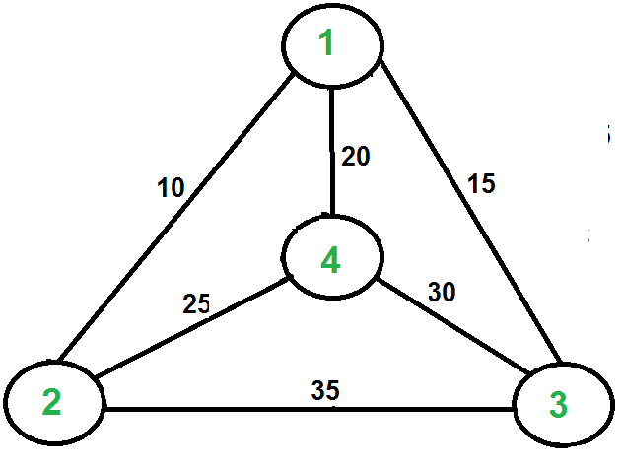

For example, consider the graph shown in the figure on the right side. A TSP tour in the graph is 1-2-4-3-1. The cost of the tour is 10+25+30+15 which is 80. The problem is a famous NP-hardproblem. There is no polynomial-time know solution for this problem. The following are different solutions for the traveling salesman problem.

**Naive Solution:**

1) Consider city 1 as the starting and ending point.

2) Generate all (n-1)! [Permutations](https://www.geeksforgeeks.org/write-a-c-program-to-print-all-permutations-of-a-given-string/)of cities.

3) Calculate the cost of every permutation and keep track of the minimum cost permutation.

4) Return the permutation with minimum cost.

Time Complexity: ?(n!)

**Dynamic Programming:**

Let the given set of vertices be {1, 2, 3, 4,.n}. Let us consider 1 as starting and ending point of output. For every other vertex I (other than 1), we find the minimum cost path with 1 as the starting point, I as the ending point, and all vertices appearing exactly once. Let the cost of this path cost (i), and the cost of the corresponding Cycle would cost (i) + dist(i, 1) where dist(i, 1) is the distance from I to 1. Finally, we return the minimum of all [cost(i) + dist(i, 1)] values. This looks simple so far.

Now the question is how to get cost(i)? To calculate the cost(i) using Dynamic Programming, we need to have some recursive relation in terms of sub-problems.

Let us define a term *C(S, i) be the cost of the minimum cost path visiting each vertex in set S exactly once, starting at 1 and ending at i*. We start with all subsets of size 2 and calculate C(S, i) for all subsets where S is the subset, then we calculate C(S, i) for all subsets S of size 3 and so on. Note that 1 must be present in every subset.

If size of S is 2, then S must be {1, i},

C(S, i) = dist(1, i)

Else if size of S is greater than 2.

C(S, i) = min { C(S-{i}, j) + dis(j, i)} where j belongs to S, j != i and j != 1.

**Implementation:**

#include <stdio.h>

#include <limits.h>

#define V 4

int min(int x, int y) {

    return (x < y) ? x : y;

}

int tsp(int graph[][V], int mask, int pos, int n, int dp[][V]) {

    // If all cities have been visited, return the cost of returning to the original city

    if (mask == (1 << n) - 1) {

        return graph[pos][0];

    }

    // If this sub-problem has already been computed, return its result

    if (dp[mask][pos] != -1) {

        return dp[mask][pos];

    }

    int ans = INT_MAX;

    for (int city = 0; city < n; city++) {

        if ((mask & (1 << city)) == 0) {

            int newAns = graph[pos][city] + tsp(graph, mask | (1 << city), city, n, dp);

            ans = min(ans, newAns);

        }

    }

    return dp[mask][pos] = ans;

}

int main() {

    int graph[V][V] = {

        {0, 10, 15, 20},

        {10, 0, 35, 25},

        {15, 35, 0, 30},

        {20, 25, 30, 0}

    };

    int dp[1 << V][V];

    for (int i = 0; i < (1 << V); i++) {

        for (int j = 0; j < V; j++) {

            dp[i][j] = -1;

        }

    }

    int start = 0;

    printf("The shortest path length is %d\n", tsp(graph, 1, start, V, dp));

    return 0;

}

Output:

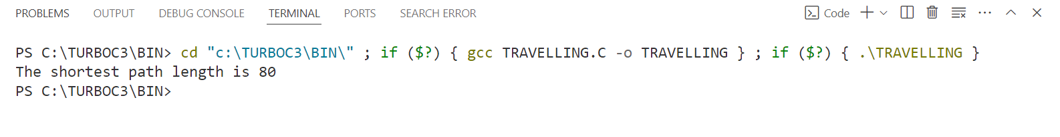

**Conclusion:** In conclusion, we have presented a C program implementing the Dynamic Programming approach to solve the Travelling Salesperson Problem (TSP). The program efficiently finds the shortest path that visits each city exactly once and returns to the original city. By utilizing dynamic programming techniques and memoization, the program reduces redundant calculations and improves performance. This solution demonstrates the practical application of algorithmic concepts in solving real-world optimization problems.